Large print

Future Wales Fellowship 2023
July 2023

Accessibility
Arts Council of Wales is committed to making information available in large print, braille, audio, Easy Read and British Sign Language and will endeavour to provide information in languages other than Welsh or English on request.
If you have any access needs and are thinking about making an application, we can help to make sure that you’re supported during the application process. Please contact us at grants@arts.walesto discuss how we can help.
Arts Council of Wales operates an equal opportunities policy.
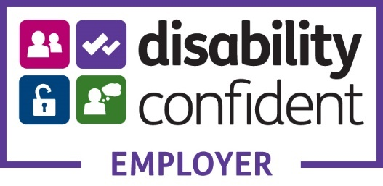

Contents
Future Wales Fellowship 4
Introduction 5
What is the Future Wales Fellowship? 7
Why are we offering the Future Wales Fellowship? 8
What the Fellowship offers artists 11
The Development Programme 13
Selection Criteria 16
Application Process 18
Eligibility 21
Accessibility 21
What if I have a question? 21

Future Wales Fellowship
In partnership with Natural Resources Wales, Arts Council of Wales is pleased to invite artists based in Wales, in particular those from under-represented backgrounds, to apply for a Future Wales Fellowship in 2023.
Deadline for applications: 5pm, 15 September 2023.
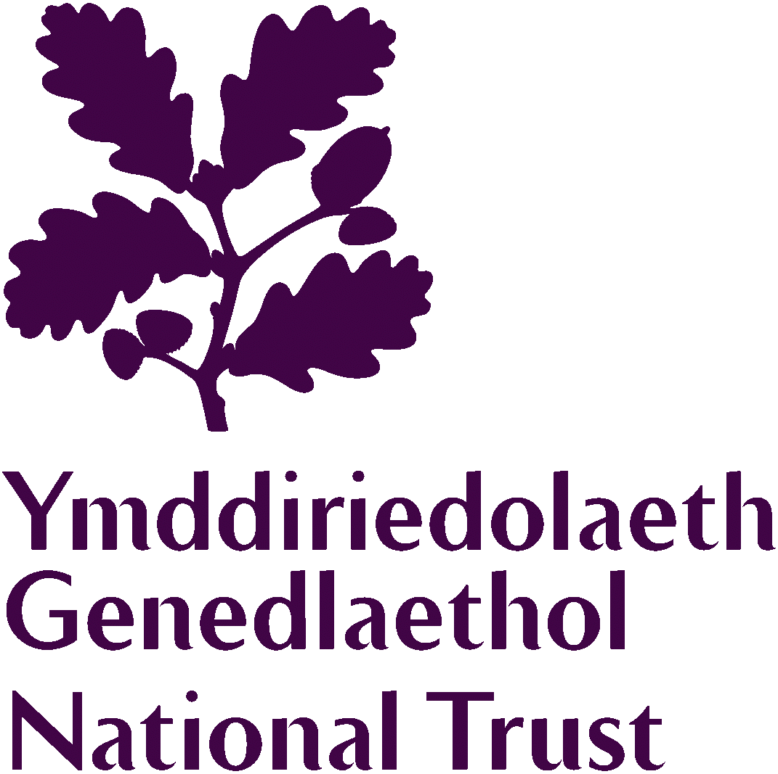
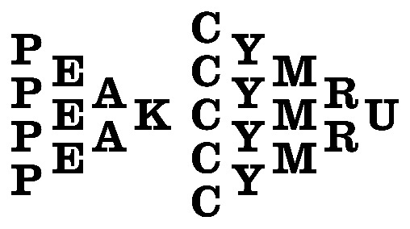
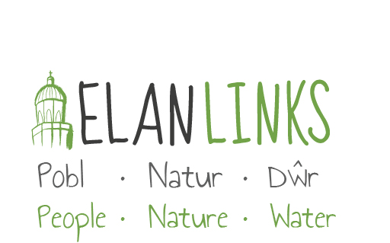
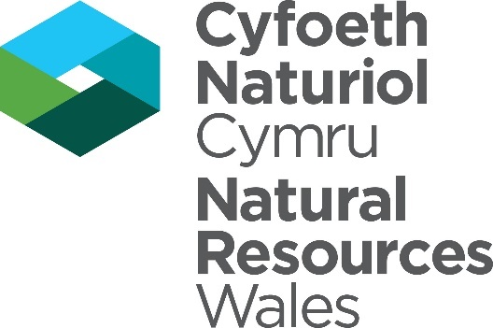

Introduction
“The relationship between self and the world is reciprocal, it is not a question of first getting enlightened or saved and then acting. As we work to heal the earth, the earth heals us.” Robin Wall Kimmerer, Braiding Sweetgrass
According to the latest IPCC report (Intergovernmental Panel on Climate Change), “The scientific evidence is unequivocal: climate change is a threat to human wellbeing and the health of the planet.” Climate change affects all of us, but not evenly. At home and globally, those who have contributed the least to climate change are often the most impacted. In order to address the climate and nature emergencies, every one of us will need to make changes to our daily lives, and we must put equality and justice at the heart of our actions. This approach is called climate justice.
Safeguarding and strengthening nature is key to securing a liveable future for ourselves and future generations, and urgent and global action is needed.
More than ever, we need to care for nature but never have we felt more disconnected from it. Scientists tell us that how ‘connected’ we feel to nature plays an important role in the way that we act towards it, as well as improving our happiness and wellbeing. Nature connection is grown by actively noticing, appreciating and caring for nature, not just through spending time in nature. It is not enough for us to know there is an emergency, we need to build a deeper relationship with the planet we live on and take action to protect it.
In Wales, our creativity, language and culture are an integral part of who we are and how we connect with nature. Understanding this is an important part of helping us change our relationship with the natural world.

What is the Future Wales Fellowship?
The Future Wales Fellowship is a grant of £25,000 each for 8 individual artists or creative individuals to spend 16 months undertaking creative research on the theme of “connection to nature”. It is an opportunity to challenge understanding our relationship to nature and how to reconnect with it, and to explore your own relationship with nature, and that of the people and communities around you.
Fellows are invited to look through the lens of lived experience. You may wish to consider social injustice, colonial legacies and the impact of climate change on the natural world, listening to stories and traditions and making space to challenge the status-quo.
The Fellowship makes space for reflection and personal development and also for action. Your research can be global or hyper-local. It can be expressed in any creative medium or process, to reimagine and disrupt current ways of thinking and offer new possibilities.
Your starting points for research may consider any angle on the theme of connection to nature.

Why are we offering the Future Wales Fellowship?
The Future Wales Fellowship is part of the Creative Nature Programme between Arts Council of Wales and Natural Resources Wales.
The purpose of the Creative Nature Programme is to help to cultivate the relationship between the arts and the natural environment, as part of a shared commitment to improve the environmental and cultural well-being of Wales. We believe that both nature and the arts can help promote wellbeing and improve the quality of people’s lives, which has led us to set the theme of “connection to nature” for this second iteration of the Future Wales Fellowship.
For this Fellowship, we are joined by the National Trust and Elan Valley Trust, who share in these organisational aims.
As organisations, we're asking ourselves the following questions:
- How can the arts help us develop a deeper relationship with nature, and inspire people to make the changes we need to make as a society at the pace and scale that is needed?
- Who has responsibility for nature? How can we help more people feel able to shape the future of our planet?
- How does our relationship with nature shape our society? How does our society shape our relationship to nature?
- What are the stories that shape our connection to nature, and how could this narrative grow into one that will let us live within our global means?
- How can we use creativity to explore the relationship between our unique Welsh language, culture and history and our landscapes?
- What can we learn from local and Indigenous wisdom and knowledge, in Wales and globally?
As part of the Fellowship process, we will create a space for exchange and dialogue with the Fellows which will enable us to consider these questions within our organisations through different challenges and perspectives the Fellows may have.

What the Fellowship offers artists
The Future Wales Fellows will receive a grant of £25,000 for a 16 month Fellowship from December 2023 to March 2025. The grant is divided between payment for your time of £15,000 (for approximately 60 days) and a budget of £10,000 to support materials, production and individual self-directed mentoring and training needs. For this, the Fellows will:
- develop creative research that addresses the themes of the Fellowship and engages participants and audiences.
- participate in a development programme hosted with Peak Cymru, combining curatorial dialogue, mentoring and support, collaborative conversations about ideas, research and work in progress, and 3 in-person, three-day residential visits with guest practitioners. Whilst the Fellowship has been designed to be flexible around existing commitments, Fellows will be expected to prioritise the structured development programme and to engage with the other Fellows during the Fellowship period.
- share your practice and process as part of wider, cross-sector conversations exploring our relationship with nature via 1-2 public events across the duration of the Fellowship.
- provide a final report of what they achieved and learnt and participate in the programme evaluation.

The Development Programme
For the second year of the Future Wales Fellowship, Peak Cymru has been selected (following an open call application process) to co-host the development programme for the Fellows, working in collaboration with arts manager and creative producer Elen Roberts. Peak’s work on the Future Wales Fellowship begins December 2023, following the selection of the Fellows by NRW and ACW.
The development programme will offer each Fellow bi-monthly conversations to support curatorial dialogue and mentoring; collaborative group conversations about ideas, research and work in progress, and 3 in-person, three-day residential visits with guest practitioners. The residentials will introduce Fellows to the knowledges and practices of partners, peers and cross-disciplinary practitioners – exploring and expanding on human relationships with nature, anchored in the context of partner organisation sites.
In summary Fellows will participate in:
- Three, three-day residential visits with guest practitioners (in person)
- Three group meetings, ahead of each residential (online)
- Five 1-2-1 check in meetings (online)
- Three 1-2-1 curatorial mentoring sessions (online)
- Opportunities to learn from and respond to sites managed by Natural Resources Wales, The National Trust and the Elan Valley Trust
Confirmed dates for the diary:
- Wednesday 6th or Friday 8th December 2023: 1-2-1 check in meeting (online)
- Wednesday 24th January 2024: Group meeting, ahead of first residential (online)
- February 2024: First residential (in person)
- Wednesday 15th May 2024: Group meeting, ahead of second residential (online)
- June 2024: Second residential (in person)
- Wednesday 18th September 2024: Group meeting, ahead of third residential (online)
- October 2024: Third residential (in person)
- January 2025: Group meeting, programme reflection/evaluation (online)

Selection Criteria
Applications will be assessed against the following criteria:
- The quality of creative practice. You will need to show evidence of an established track record of at least 5 years and of being at a point in your career to significantly benefit from the time and development the Fellowship offers.
- The extent to which your research interests and/or starting point reflect the themes of the Fellowship. Please tell us about how your experience and current or previous projects/research have informed your starting point. We are keen to receive applications from practitioners with experience and/or interest in participatory practices and cross-sector working.
- The viability of your research within the time and resources allocated. You will need to demonstrate that you are able to dedicate around 60 days of your time over the 16 month Fellowship period. Please tell us about your other commitments during this time frame.
- The extent to which your proposal engages with Arts Council of Wales’s priorities around equality, diversity and the Welsh language.
- The potential for the award to impact on your creative development and the contribution it will make to the environment and culture of Wales in the future.
In addition to these basic selection criteria, the panel will take into consideration the overall diversity of the 8 artists selected.

Application Process
- You’ll need to use our online ‘portal’ to make an application. If you haven’t done so already, you’ll need to register for access to the portal. You can find out how to do this here.
- If you’re unable to access the online form or require further assistance, please contact us at grants@arts.wales
- Complete a Future Wales Fellowship application form on our online portal. Guidance for completing the form is available online. We recommend you allow time to familiarise yourself with the form and questions you will need to answer.
- Upload the following additional material in your submission:
- An outline of your proposed research or starting points for research which shows how it addresses the criteria above. This can be provided in text or audio/video format. This can be a maximum of 2 sides of A4 text or 4 minutes of audio or video.
- A budget to outline how you would use the grant. This needs to include your travel costs to attend the 3 planned in person gatherings (accommodation and catering will be covered by Arts Council of Wales). If you invite other artists to collaborate their fees should be paid from the grant. You can include access support costs in addition to the £25,000 grant amount.
- Evidence of work, to include up to eight examples of previous work as still images, text or links to a video showreel from an online resource such as your website, Vimeo or YouTube. Showreels should be a maximum of 4 minutes and available online from 5pm on 15 September 2023 until 31 October 2023.
- CV (maximum 2 sides of A4).
This submission should be contained in a single file (Word or pdf) and text should be no smaller than 12pt and files should not exceed 250MB.
All video and audio material must be provided as links to your website, Vimeo or YouTube. Please remember to include security information if links are password protected.
After we receive your application, we’ll send you an acknowledgement.
- If your application is eligible, it will proceed to assessment.
- If your application is successful, we’ll send you an Award Acceptance.
- Once you’ve signed and returned your Award Acceptance and we’ve verified your details, we’ll release 60% of the award. 30% will be released to you during the project and we’ll pay the final 10% at the end of your project.
Decisions will be communicated by 31 October 2023.

Eligibility
- Applicants must be based in Wales and be able to apply in the legal name of the individual making the application.
- Have a bank account in your legal name. You can find out what you need to submit here.
- We will not accept proposals from applicants currently in full-time formal education, including postgraduate study.

Accessibility
Please get in touch with our Grants and Information Team to discuss how we can help with specific access needs.

What if I have a question?
If you want to clarify if you or your application is eligible, or you wish to discuss other questions about this fund, please contact our Grants and Information Team. You can do this by email, through our website or social media: grants@arts.wales
We’ll do our best to respond to all enquiries as promptly as we can. If you want us to call you back, please provide your contact number and we’ll arrange to get back to you as soon as possible.
There are other ways you can contact us:
Telephone: 03301 242733 (all calls charged at local rates)
Hours: 9.00am-5.00pm Monday–Thursday, 9.00am-4.30pm Friday
Twitter: @Arts_Wales_
Website: arts.wales
Instagram: @celfcymruarts

