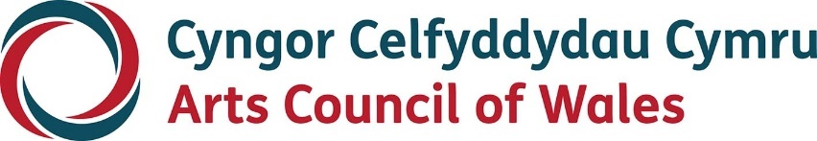

Large print

Creative Steps for Individuals

Guidelines

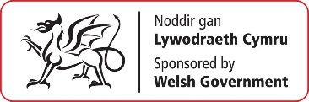
November 2022

Accessibility
Arts Council of Wales is committed to making information available in large print, easy read, braille, audio and British Sign Language and will endeavour to provide information in languages other than Welsh or English on request.
We operate an Equal Opportunities Recruitment Policy and welcome applications from all sections of the community in Welsh or English. There will be no delays in correspondence due to language preference.
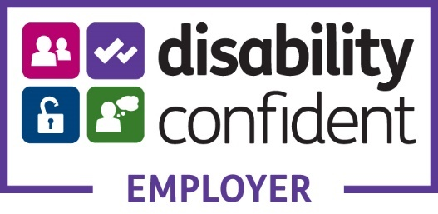

Contents
Creative Steps for Individuals 4
Welcome 4
About Creative Steps for Individuals 4
How can we help and what can I apply for? 8
Who can apply? 12
How much can I apply for? 13
Application Deadlines 14
Next Steps 15
Contact us 17

Creative Steps for Individuals

Welcome
Welcome to Creative Steps for Individuals – one of our National Lottery funding programmes. This information sheet will tell you about applying to Creative Steps as an individual.
If you think Creative Steps for Individuals is for you the most important thing to do is to talk to an Arts Council Officer. This will help us work with you to find out whether this scheme is right for you and will help us to meet your needs. If it is, then we’ll support you as best as we can to apply for Creative Steps funding.

About Creative Steps for Individuals
Some artists and creatives are more likely to have experienced barriers to accessing resources and opportunities, such as funding from Arts Council of Wales.
As well as working to make all our other funds more accessible, Creative Steps for Individuals aims to address this by supporting these artists and creatives to develop their creative journey.
Creative Steps for Individuals is about supporting artists and creatives who identify as being ethnically and culturally diverse, anyone who has experienced racism or discrimination and Deaf, disabled and neurodivergent artists and creatives. This scheme focuses on these particular groups because research, both internally and externally, tells us that people from these backgrounds and lived experiences have not been able to access our funding easily, and have faced barriers and/or discrimination. Support for these artists and creatives is vital to help increase the range of high–quality artistic work being created and presented in Wales by diverse artists. We want to champion people with these lived experiences.
We define ‘ethnically and culturally diverse’ as:
• Anyone from the African, Asian, Caribbean, Hispanic, Latino, Eastern European or Middle Eastern diaspora in Wales
• Anyone who identifies as being from an ethnic group that is not exclusively White
• Anyone from Gypsy, Roma and Traveller Communities
We also want to support you to overcome any barriers to receiving funding that you may have experienced. We will do this by providing more flexible support throughout the application process.
We define ‘disability’ using the Social Model of Disability:
• The social model of disability is a framework that was developed by disabled people to identify and take action against their oppression and the framework states that people are disabled by barriers in society and not necessarily by their impairment. Barriers could be physical such as a lack of disabled toilets or they can be attitudinal such as assuming disabled people can’t do certain things.
• The social model of disability was developed to directly counter the traditional, medical model of disability which perceived disabilities and impairments to be a medical problem to be prevented, cured or contained, making the disabled person feel like the problem instead of society
We define ‘neurodiverse’ or ‘neurodivergence’ as:
• Viewing neurodevelopmental differences as a natural and normal variation of the human genome which urges society to reject any entrenched negativity associated with those that learn things in a certain manner or those that experience life in a different manner from a neurological perspective
• We all have unique nervous systems with a unique combination of abilities and needs
• We recognise that there is no ‘right’ way of thinking, learning and behaving and these differences should be celebrated rather than be perceived as deficits

How can we help and what can I apply for?
Through Creative Steps, we can be more flexible in the way we help you with your ideas and we can also guide you through the application process. We can also be more flexible about the type of proposal we fund and how much funding we can offer.
We can help you apply to our funding by:
• Helping you shape your proposal to best meet your individual needs
• Supporting you to partner with someone who will be able to work things through with you such as an Arts Council Officer, an Arts Associate or we may be able to cover the cost of getting a professional from outside of the Arts Council to help you. We will also provide applicants with a list of potential consultants that may be able to assist you with your application and provide you with support and guidance. For example, these consultants could help you with your artistic development or marketing strategy, amongst other things.
• Providing support as you write your application. For example, we can provide support for you if you would like to submit your application in a different format such as a video instead of a written application.
Your project could include but is not limited to the following:
• Making work which will progress your creative journey
• Working with someone with similar experiences to you to help you work out what steps you need to take next if you’re unsure
• Developing the resources and the skills you need such as a website, marketing materials, using spreadsheets and budget management, fundraising or social media presence
• Training courses relating to your creative journey (but not formal education such as degree courses)
• Setting up groups with other artists to learn together and from each other
• Working with someone with professional experience to support you as you take next steps in your creative journey (sometimes called a mentor)
• Making your practice more professional (accessing business development advice on areas such as setting up as an organisation for example)
You can also include the following:
• Costs of your own time
• Access costs
• Costs for childcare or other caregiving responsibilities
We know this is not an exhaustive list. Everyone’s needs and journey is unique, and we aim to be as flexible as possible. We will also consider supporting:
• Applications up to £10,000 (plus access costs)
• Applications that request up to 90% of the total eligible cost of the proposal
We’ll support you to shape a project that’s focussed on you taking the next steps in your creative practice or your creative journey.
Think about where you are currently, where you want to be, and the things that need to happen next for you to get closer to that goal. That will be the basis for a project. Or, if you’re not sure what your creative journey should be, then we can support you to work this through with someone first.

Who can apply?
Creatives Steps is open to individual artists and creatives that are ethnically and culturally diverse, deaf, disabled, neurodivergent or those that have experienced racism or discrimination.
You must be based in Wales.
You must be 18 or over (there’s no upper age limit) and not be in full time education.
You must have experience as an artist or creative professional for at least one year. You may have had breaks and your artistry does not have to be your main source of income, but you must have demonstrable artistic or creative experience.
You must have some experience of making and sharing work with others (a performance or exhibition for example). For those that do not have this experience, we may still be able to support you as long as you submit a portfolio to us with your application.

How much can I apply for?
You can apply for funding between £500 and £10,000.
Please note that if you apply to us for a period of more than one year, we will need to monitor what you've achieved in your first year before we agree to fund the next year. We will set clear targets for each year and discuss whether you have met these before we can move on.
Please note, we cannot guarantee long–term Arts Council of Wales financial support once your project has ended. You must develop a sustainable practice which does not rely solely on our funding to support your ongoing development.
We cannot fund the total costs of your proposal. The maximum percentage of your total eligible project costs that we can fund is 90%. The remainder of your income must come from a non–Arts Council of Wales or National Lottery source. This can be ‘in–kind’ support or cash, or a combination of both. If this is a barrier, in exceptional circumstances we will fund up to 100%.
Support in kind can be a non–cash contribution to your project. For individuals applying to us, there is no limit on how much in–kind support you can include in your budget. Please note that support in–kind cannot be from your own resources. It can be, for example, donated rehearsal or studio space or loan of equipment.
In your discussions with an Arts Council Officer, they will advise you about what would be an appropriate amount for you to apply for.
You will still be eligible to apply for other Arts Council funding strands.

Application Deadlines
The deadline for submitting applications to the Creative Steps programme is the last day of each month. The first closing date will be 31 December 2022 and following this, it will be on a monthly basis.
If your application is up to £10,000, please bear in mind that you need to allow a minimum of 6 working weeks between the deadline date and the start date of your project.
We cannot fund proposals that are already happening so we won’t accept your application if your proposal’s start date will come before we’ve had the opportunity to assess your application.

Next Steps
If you think Creative Steps for Individuals could help you, please contact us so we can work together on the next steps.
Once you’re in touch with one of our Officers, they will:
• Discuss your ideas and plan how to best meet your creative needs.
• Work out with you what level of funding is appropriate.
• Provide guidance and assistance to partner you with someone to work though this with you and help shape your ‘next steps’ into a project.
• Provide support to put your application together (this might come from an Arts Council Officer, an Arts Associate or we may be able to cover the cost of getting a professional from outside of the Arts Council to help you).
• Support you to apply in a different medium such as by video.
• When relevant – and if it’s of interest to you – invite you to take part in learning opportunities with other Creative Steps awardees.
If you’re successful, we’ll be on hand to support you. We hope things go well but we also want you to be honest and open if things do not go so well so that we can help. At the end we’ll discuss what happened and future options including further funding. We will ensure that communication is always open and transparent.
If you’re unsuccessful, we’ll still be on hand to support you. We will work through the reasons why, and what you can do next to take things forward and possibly reapply. This isn’t pass or fail but a process. Again, we will ensure that communication is always open and transparent.
Here are the ways you can get in touch. One of our officers will introduce themselves and start conversations in your preferred medium.

Contact us
Telephone: 03301 242733
Email: creativesteps@arts.wales
Hours: 9.00am-5.00pm Monday to Thursday, 9.00am-4.30pm Friday
Website: www.arts.wales/about–us/contact–us
Facebook: Cyngor Celfyddydau Cymru | Arts Council of Wales
Twitter: @Arts_Wales_
Instagram: celfcymruarts

