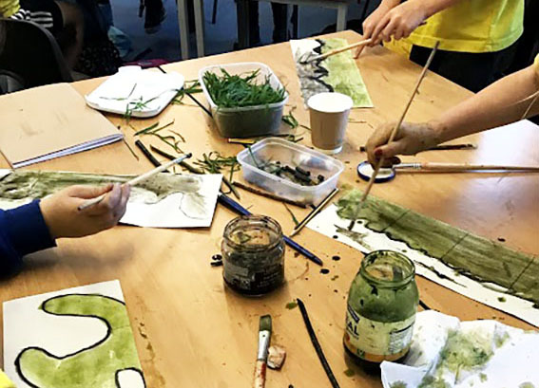
Large Print

Go Creative Fund

Creative learning through the arts

September 2021

Contents
Go Creative Fund 3
More about the Go Creative fund 3
What will we pay for? 4
Eligibility criteria: 5
Selecting your Creative Practitioner 5
Understanding Creative learning approaches 6
How to apply 6
Deadline for applications 9
Find out more 9
Creative Fund application top tips: 10

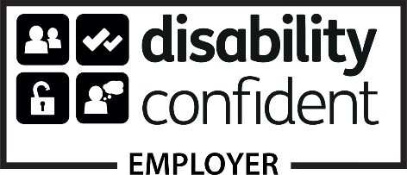
Arts Council of Wales is committed to making information available in large print, braille, audio, Easy Read and British Sign Language and will endeavour to provide information in languages other than Welsh or English on request.

Front cover: Ysgol y Ddwylan

Go Creative Fund
The Creative learning through the arts programme is providing funding for schools in Wales to work with their learners and teachers alongside Creative Practitioners to focus on developing new and exciting ways to engage learners.
The programme has consistently demonstrated how creative approaches to teaching and learning can develop creative skills that transform the learning experience for all learners. We know that collaborative, creative approaches that involve learners, teachers and Creative Practitioners increase and improve engagement, confidence, well-being and achievement.
Utilising the successful approaches and techniques from our ground-breaking and internationally recognised Lead Creative Schools Scheme, the Go Creative Fund will use the Creative Habits of Mind and the High Functioning Classroom to nurture creativity in the classroom.

More about the Go Creative fund
The Go Creative fund is a simplified version of our Lead Creative Schools Scheme. The fund is designed to offer teachers the opportunity to work with a Creative Practitioner to experiment with combining creative pedagogy and artistic practice to bring about new and fresh approaches to learning. Schools can apply for a grant of £1000 to work with a creative practitioner for four days to support them in providing creative approaches to learner engagement.
The range and type of activity that could be supported is wide open: it could focus on a theme, topic or Area of Learning and Experience. It could engage learners through discussions and sharing creative ideas. Pupil voice could be used to encourage learners to collaborate and design the activity. Activity could spark learners’ imaginations and encourage them to question the world in which they live. They could develop new skills and techniques with the support of a creative practitioner. Activity will support learners to develop and share their learning between sessions in imaginative and creative ways. The possibilities are endless.
The important thing is that the application demonstrates how the proposed activity will use creative learning approaches to support learning.

What will we pay for?
• Schools will receive a grant of up to £1,000 to be spent on Creative Practitioner delivery time only. This does not include travel costs or materials.
• Activity must take place across a total of four days, or equivalent. These can be consecutive days or divided into half days or shorter sessions spread over several weeks.
• Schools can only work with one Creative Practitioner and we expect creative practitioners to be paid £250 per day or £125 per half day.
• A full/half day’s delivery should include planning and reflection time.
If required, any costs needed for materials or equipment for the activity will need to be met by the school.

Eligibility criteria:
• Available for any state-maintained schools (Reception – KS4).
• Schools must agree to designating a teacher to apply and take part in the activity on behalf of the school. This does not need to be a teacher within the Expressive Arts Area of Learning and Experience.
• The participating teacher should watch the Introduction to Creative learning film (see further down this guidance) so that they gain an awareness of the Creative Habits of Mind and the High Functioning Classroom.
• Schools will be asked to submit a short reflection on what has been achieved by taking part. This may be accompanied by images, film, written work, testimonials from learners and or staff.

Selecting your Creative Practitioner
We expect schools to identify a practitioner prior to applying to this fund.
The Creative Practitioner can be someone you have worked with before, or you may wish to use Plwg to put out a call out for a Creative Practitioner to work with your school. In most cases we expect schools to work with a Creative Practitioner who has already participated in a Lead Creative Schools Scheme project. However, if you wish to work with a Creative Practitioner who has not attended our Lead Creative Schools training, they will need to watch the Introduction to Creative learning film in advance of planning and delivering your activity with you and your learners.
Schools are responsible for paying Creative Practitioners and ensuring they hold a valid enhanced DBS certificate.

Understanding Creative learning approaches
In order to gain an awareness of the Creative Habits of Mind and the High Functioning classroom, we ask participating teachers and Creative Practitioners to watch the film on the main grant page. In the application you will need to demonstrate how you will use these two tools to support your activity.

How to apply
Applications must come from a school. You’ll need to register your school on our online portal before completing an application form. Once you have registered on the online portal you will be able to access the application form. We recommend that you register your school on our portal at least 5 working days before you wish to start your application.
If you require further assistance in accessing the online portal, please contact us via: 029 2044 1300 or 03301 242733 (helpline) local call rate is charged.

Creative Habits of Mind
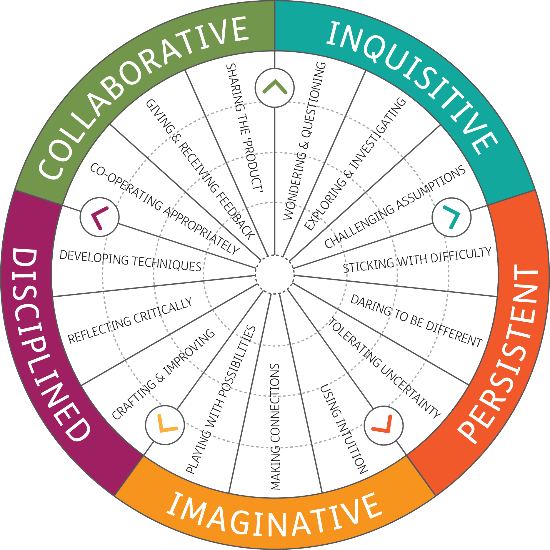

High Functioning Classroom
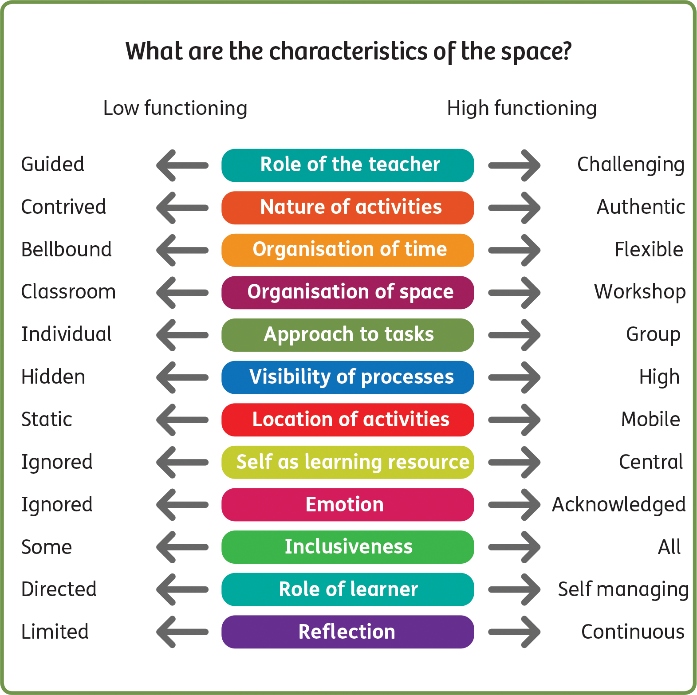

As part of your application we will ask you to describe the activity you wish to fund. We’ll be looking out for the following information:
• The theme, topic or area of learning for the activity has been decided by the school.
• How you will use the Creative Habits of Mind and the High Functioning Classroom to support your activity in order to benefit learners, particularly their engagement with learning and wellbeing.
• The learners, why you chose them and how you hope the activity will help them to reengage with the curriculum.

Deadline for applications
There is an ongoing assessment process for the Creative learning recovery fund, which means schools can apply for funding at any time. In most cases you will normally hear within 4 weeks whether your application has been successful or not, so we would encourage you to submit your application at least 5 weeks before you wish your activity to start to give yourself enough time to prepare.

Find out more
If you have questions about your application to the Go Creative fund, you can contact us at creative.learning@arts.wales

Creative Fund application top tips:
• If your school has received any previous funding from us, please make sure that you have returned a completion report so that your grant can be closed. We are unable to accept another application from you until this has been completed.
• This programme is ring fenced for school aged children starting from reception up until the age of 16. Please note that we are unable to fund post 16 education, including FE Colleges and Sixth Form.
• In competitive funding rounds priority will be given to schools that are yet to benefit from Creative learning through the arts funding.
• We cannot fund capital expenditure, e.g., purchasing equipment.
• Please make sure you include the name and email address of your intended Creative Practitioner before submitting your application.
• Please make sure you submit your application no less than 5 weeks before you wish to commence your activity.
• Make sure your application focuses on learning in a creative way rather than taking part in an arts activity.

