Can you be an

“Agent for Change”?

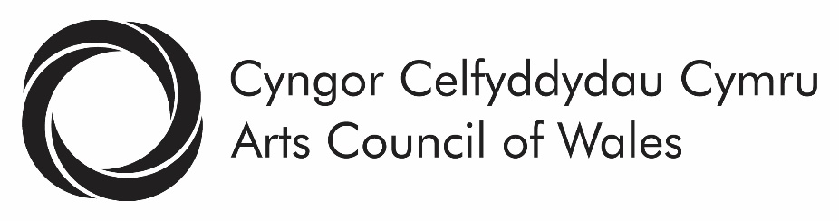

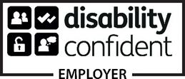

Arts Council of Wales makes information available in large print, braille, audio, Easy Read and British Sign Language. We’ll also try to provide information in languages other than Welsh or English on request.
Arts Council of Wales operates an equal opportunities policy.

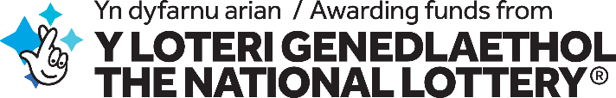
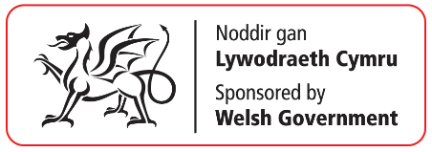

The Arts Council of Wales wishes to transform how we engage with and develop opportunities for people from Black, Asian and Ethnically Diverse backgrounds and Deaf and disabled people to enjoy, take part and work in the Arts.

Arts Council of Wales is the official public body that develops and funds the arts in Wales. We offer grants with money that we receive from the Welsh Government, the National Lottery and other sources of public and private support.

Our “vision” is of a creative Wales where the arts are central to the life and well-being of the nation, making our country an exciting and vibrant place to live, work and visit. This means recognising the cultural entitlement and creative needs of all individuals and communities across Wales.

The world looks very different today than it did before Covid-19. We know that change is needed across the arts in Wales – including at the Arts Council of Wales. For too long Black, Asian and ethnically diverse people along with Deaf and disabled people and artists have been denied opportunities to create and present their own art or to work in the arts in Wales on their own terms. Funding statistics tell their own story – and it’s not a good one –diversity across the arts sector as a whole is falling short.

At the Arts Council we want to improve the diversity of and transform our Council (our board of governance) and staff. We also want to foster and drive change in the organisations we fund.

If you feel you can be the one to help us drive these changes, we’d like to hear from you.

Arts Council of Wales is changing …

People with lived experience are telling us loud and clear that we and many others working in the arts are continuing to reinforce discrimination, falling short of inclusion and equality standards.

Diversity has been a long-standing priority and we’ve made progress in some areas. But we know we need to do much more, and quickly.

We acknowledge structural inequalities within our own organisation and across the arts in Wales. In particular, we recognise the pain and trauma that structural racism and ableism inflicts. Power and privilege are serious barriers to equality, representation and inclusion.

The time for urgent action, for structural and permanent change and for processes of truth and reconciliation is now. The Arts Council accepts its responsibility to make sure that this happens.

We’ve made a clear commitment to change. This is set out in our Black Lives Matter statement and in our support of the Seven Inclusive Principles for Inclusive Recovery for the arts that have grown out of the #WeShallNotBeRemoved campaign.
https://arts.wales/news-jobs-opportunities/black-lives-matter-0
https://arts.wales/news-jobs-opportunities/working-safely-through-covid-19-seven-inclusive-principles-for-arts

Commitment is all very well, but communities are telling us that this is not the time for ‘conversations’ but for action. We need to translate our commitment into action, and the “Agent for Change” will help lead this.

What would you be doing as the “Agent for Change”?

We’re asking the “Agent for Change” to use their knowledge and expertise to identify/call out the barriers that prevent inclusion and develop actions for change; to lead a process of cultural change within the Arts Council itself. The work will be shaped and developed by your knowledge and lived experience of being an “Agent for Change”.

You’ll work alongside the Council and staff of the Arts Council, connecting with and drawing on the lived experiences of diverse artists in the communities of Wales. Your involvement will range across all areas of our work and support the awareness and professional development of our staff. You’ll be supported to change the way we work, to identify and call out the barriers that prevent inclusion. Our ambition is that all staff and members of Council, current and future, become “Agents for Change”.

This role, and its programme of work, will be shaped by you. So we’re not going to set out everything in advance. However, seven things will be especially important:
- Initiating and leading work to make our policies, plans and funding more accessible for Deaf and disabled people and for Black, Asian people and people who are ethnically and culturally diverse

- Developing networks with individuals, groups and organisations in Wales that are under-represented in the arts in Wales, especially those from minoritised groups and who have experienced racism and ableism in the arts

- Working with Welsh Government, National Assembly and its Committees (as appropriate)
- Identifying and implementing steps to increase the diversity of Council and its staff

- Supporting us as we define new expectations and targets for our Arts Portfolio Wales (our nation-wide network of revenue-funded organisations)

- Identifying and developing appropriate training for Arts Council staff and the wider arts sector

- Developing transparent and robust approaches to how we monitor, evaluate and report on the impact of our work

What are the skills and expertise that you’d bring to the role?

You’ll be an exceptional individual, passionate about equality, human rights and enthusiastic about our goal to make the arts in Wales fairer, diverse and representative of its communities.

The most important qualification for this role is that you’re able to use your lived experience and ability to engage with other under-represented communities to help us find practical solutions in those areas of our work where we need to do better. We recognise the non-traditional routes and developmental journeys that many individuals have followed through their work and we value lived experience as expertise.

You’ll have an understanding of developing the equalities agenda or have been involved as an activist in other campaigns, helping communities to tackle discrimination and secure fair access to funds and resources. We recognise that candidates will not necessarily have experience in all the equality agendas we wish to drive progress in, but we are committed to providing tailored additional support where that is the case. An understanding of the context within Wales will be an asset to this role. You will be articulate and persuasive, well-used to finding new and imaginative ways of finding practical solutions.

Our commitment to supporting you

At Arts Council of Wales we recognise that change is not always a comfortable process. We’re ready to be challenged and accept that addressing our own structures of privilege and power, institutional culture and deepening our understanding will be part of this process. This is likely to be a challenging role, so we’ll put in place a support group to help and guide you in your work. The group will be made up of Council members and people with specific lived experience who are independent from the Arts Council.

We recognise that change takes time and that a period of research and acclimatisation may be necessary at the start of this journey. This is reflected in the length of contract that we’re offering.

So, now you’ve heard what we’re trying to do, are you interested in working with us?

This is a vitally important role for us, and an exciting opportunity to work at the heart of the arts in Wales. We’re especially keen to hear from Deaf and Disabled people and people from ethnically diverse backgrounds under the positive action rules of the Equality Act 2010.

This is a two-year programme of work, with the possibility of extending it for a further year.

The work could be delivered in a number of different ways and we’re keeping an open mind about the best way to move forward. For example, you might work with us through a contract for services or on an employed basis. We’ll be flexible in funding the right approach that works. Council has determined that this role should be at the heart of our decision-making. You’ll have regular contact with Council members and work alongside our senior leadership team to inform and influence decision making, reporting directly to the Chief Executive.
The salary/fee for this role is £59,269 per annum.

The approach to delivering this work will be identified through the selection process. This process will help us to decide the best way of delivering the role and its programme of work. Contracts, terms and conditions and a detailed work plan will then be agreed in conjunction with the successful applicant.

Selection for the role will be undertaken by a group that will have lived experience as an integral part of its make-up. The selection criteria will be specifically based on the outcomes identified in this brief.

If you’d like to find out more, please contact Carys Hedd Paschalis, Head of Human Resources at: hr@arts.wales

How to apply

We want the application process to be as fair and equitable as possible. We pledge to make reasonable adjustments in order to achieve this. Please get in touch if there are any adjustments we could make or additional support we could offer in order to assist you in applying. We’ll come up with suitable alternative options together. If you need information in other formats or help to apply, do contact us via the email address above.

We’re not asking you to complete a formal application form. Instead, we’re asking you to submit an “Expression of Interest” explaining in your own words why you’d like to be considered for the role. We’re asking you to do this by sending us a letter that includes the following information:
- Telling us why you are interested in this role
- Describing the specific knowledge and experience you feel that you’ll bring to the role
- Outlining how you see the role being delivered

Your letter should be sent to: hr@arts.wales

We’d be grateful if your Expression of Interest could reach us no later than Wednesday 10th March 2021.

Interviews will be held on 24th and/or 25th March 2021.

